**Question -1**

A manufacturing firm produces three products A, B & C, using the same limited resources, which is raw material, labour and processing time on the packaging machine. Product A requires 2 kgs raw material, 3 labour hours and 4 machine hours. Similarly Product B requires 5 kgs raw material, 5 labour hours, 5 machine hours and Product C requires 4 kgs raw material, 6 labour hours and 2 machine hours. The availability of raw material is capped at 90 kgs, labour hours at 130 hours and packaging machine hours at 150 kgs. The profits of product A, B & C are ` 25, ` 50 and ` 30 respectively. Answer the following questions,

1. What is the optimal output of products A, B & C to maximise the profits?

2. What is the capacity utilisation of labour hours?

3. At what profit will the Product C be viable for manufacturing?

4. Over what range of the constraints will the shadow price remain the same for the packaging machine?

5. If the 1 kgs of raw material is short, what will be the new output for Product A, B & C?

# Formulating the Decision variable, Objective function and Constraints.

## Decision Variables:

Let x1 be the manufacturing of product A

Let x2 be the manufacturing of product B

Let X3 be the manufacturing of product C

Objective function:

**Max Z = 25.x1+50.x2+30.x3, where 25, 50 and 30 are the profits of A,B and C respectively.**

**Constraints:**

The amount of Raw materials requires to manufacture product A,B, C are 2kg, 5kg and 4kgs respectively, and the total amount of Raw material that we have is given as 90kgs. Formulating that as a constraint.,

**1)2x1+5x2+4x3 <= 90**

Similarly the amount of Labour and Machine hours required to produce A,B and C are

Labour -> For product A -> 3hours

For product B 🡪5 hours

And for product C 🡪 6 hours. The total amount of labour hours we have is 130 hours in total.

**2)3x1+5x2+6x3 <= 130**

Machine Hours:

For A 🡪 4 hours

For B 🡪 5 hours

For C 🡪 2 hours. The total amount of machine hours is 150 hours.

**3)4x1+5x2+6x3 <= 150**

**4)x1,x2,x3>=0 – Non Negative constraint**

Now taking the data into excel and we will solve it using Excel solver

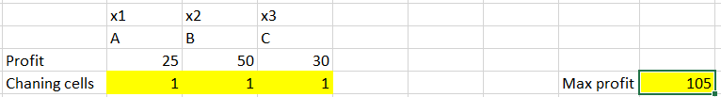

Constraint:

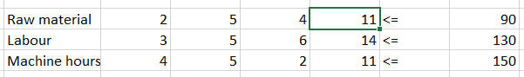

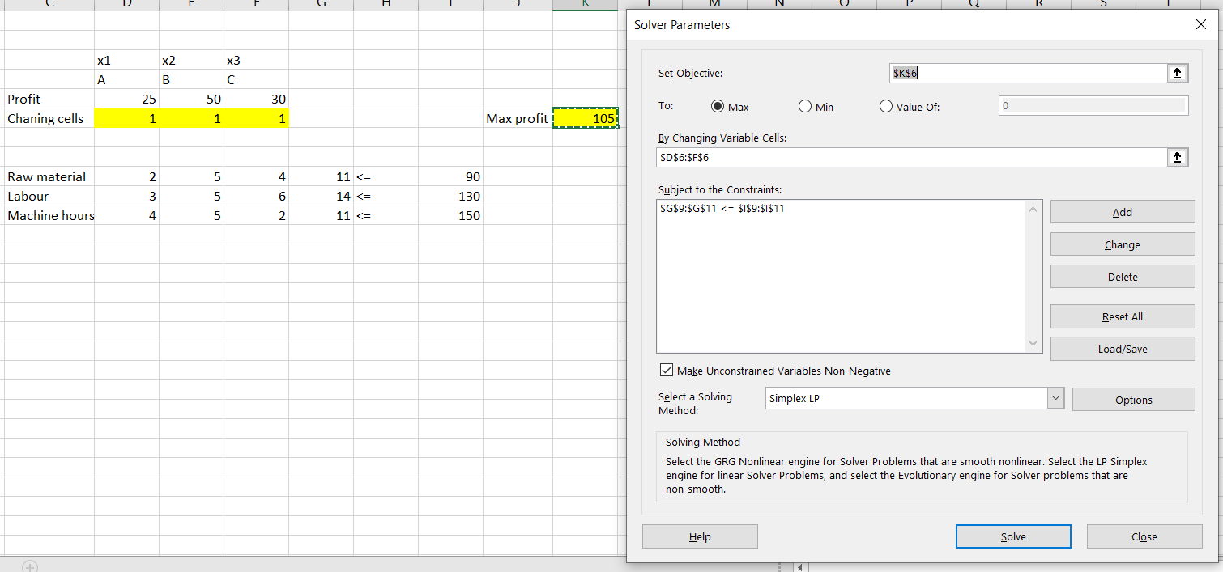

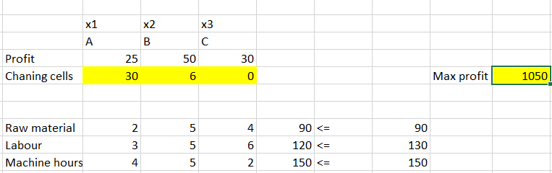

**Max profit = 1050**

**1)30 units of product A can be manufactured**

**2)6 units of product B can be manufactured**

**3))Nil of the product C to be manufactured.**

**All the constraints are satisfied and maximized profit is 1050.**

Answering the questions

1. What is the optimal output of products A, B & C to maximise the profits?

Ans:

Max profit = 1050

1)30 units of product A can be manufactured

2)6 units of product B can be manufactured

3)Nil of the product C to be manufactured.

All the constraints are satisfied and maximum profit is 1050.

2. What is the capacity utilisation of labour hours?

Ans: Labour hours is under-utilized by 10 hours, Out of 130 hours, 120 hours of labour hour is utilized. But raw material and machine hours are fully utilized.

Capacity utilization = 92 % (120/130)

3. At what profit will the Product C be viable for manufacturing?

Ans: As per the sensitivity report, Reduced cost is -5 which implies that, if we manufacture product C a loss of 5 will come. Hence an addition of 5.1 to the profit will be viable to manufacture C. As we are manufacturing products, decimals are not allowed, hence the integer constraint is added and the profit to product C is set to 36, solving using solver simplex method, we get as below,

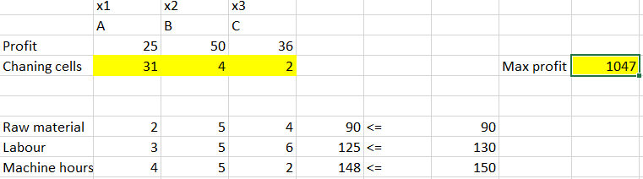

4. Over what range of the constraints will the shadow price remain the same for the packaging machine?

From the sensitivity report, the allowable increase and allowable decrease is given as 20 and 60 respectively. Thus the shadow price will remain the same between the value of constraints from 90 to 170.

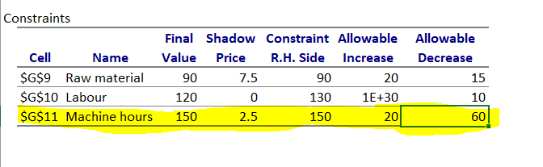

5. If the 1 kgs of raw material is short, what will be the new output for Product A, B & C?

If we reduce the Raw material constraint by 1 kg, we are getting decimal value.

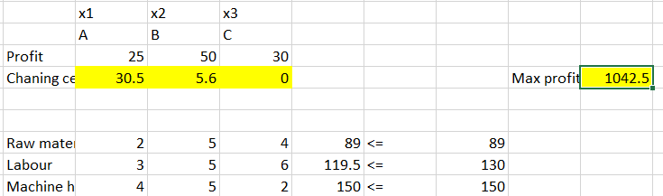

Hence adding integer constraint and solving we get a value of 30,5, and 1 respectively and the max profit is 1030.

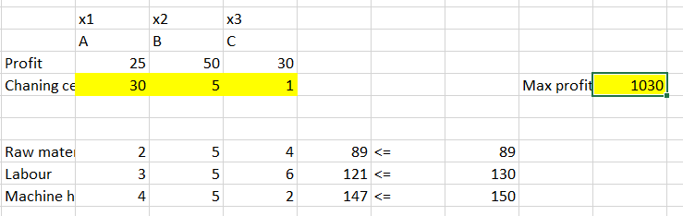

**Thus new output will be,**

**30 units of product A can be manufactured**

**5 units of product B can be manufactured**

**1 unit of product C can be manufactured.**

**Question-2**

An electronics company is engaged in the manufacture of two components C1 & C2 used in telecom tower sets. Each unit of C1 cost the company ` 6 in wages and ` 7 in materials, while each unit of C2 costs the company ` 26 in wages and ` 17 in materials. The company sells both the products on two-period credit terms but the company’s labour & material expenses must be paid in cash. The selling price of C1 is ` 40 per unit and of C2 is ` 90. Because of the strong monopoly of the company for these components it is assumed that the company can sell at the prevailing prices as many units as it produces. The company’s production capacity is limited by two considerations. First at the beginning of the period 1, the company has an initial balance of ` 18,000/- . Second the company has an available 2500 hours of machine time and 1800 hours of assembly time. The production of each C1 requires 4 hours of machine time and 2 hours of assembly time, wherase the production of each unit of C2 requires 3 hours of machine time and 4 hours of assembly time.

Formulate & solve the above problem as a LP problem.

# Formulating the Decision variable, Constraints and the Objective function

## Variables:

Let x1 - Number of Units produced of Component C1

x2 - Number of Units produced of Component C2

With the given Selling Price for each unit, we formulate the

**Total Sales** = 40x1 + 90x2

With the assumptions we formulate the constraints given:

1. The company has an initial balance of ` 18,000/-

This expense value is formulated with Wages and Material Cost per unit of C1, C2 and Units count:

**Expense Value**= [6x1 + 26x2] + [7x1 + 17x2]

Wage per unit Material per unit

= 13x1 + 43x2

## **13x1 + 43x2 <= 18,000**

1. Hour availability of Machine time

Machine Time constraint for the number of Units will be as below:

## **4x1 + 3x2 < = 2500**

1. Hour availability of Assembly time

Assembly Time constraint for the number of Units will be as below:

## **2x1 + 4x2 < = 1800**

1. The number of Units would be considered non-negative

## **x1, x2 >= 0**

## Objective Function, Z

Our goal would be to **Maximize** the below value

Z = [40x1 + 90x2] – [13x1 + 43x2]

Total Sales Expense Value

Maximize Z = 27x1 + 47x2

# Solving using Excel Solver

The number of Units of C1 and C2 are kept to be the changing cells with a value ‘1’ while solving using the Excel Solver, as we would require the information of how many units of each component will have to be manufactured with the given constraints and goal.

Given the Selling Price per unit and above assumptions of Units, we can compute the **Total Sales** value as given:

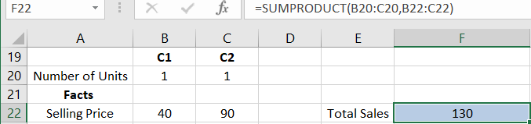

Constraints

1. Company has an initial balance of 18,000.

With a limit of 18,000, we compute Expenses using the Wages and Material cost per unit of C1, C2 and Units count as given below:

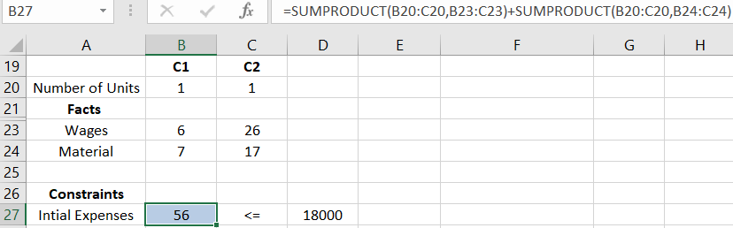

1. Hour availability for Machine and Assembly Time

With a limit of 2500 hours of machine time and 1800 hours of assembly time, we get the below values for Units count:

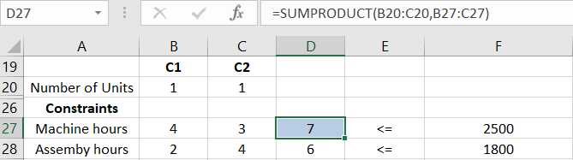

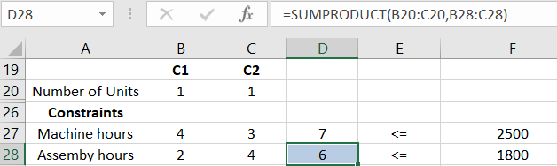

1. The Units produced will be non-negative

Objective cell would be the difference value of Total Sales and Expenses value.

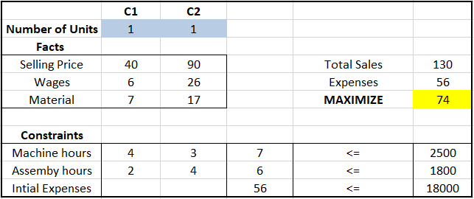

With the formulated Constraints and Goal, we will use the Solver as shown below and find the required fields.

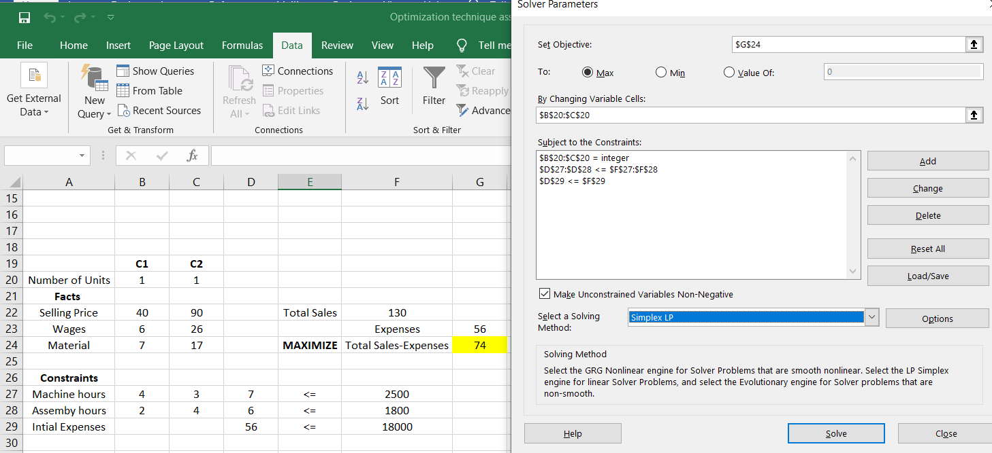

Solving the problem, we get the below output.

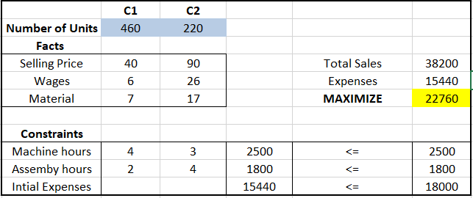

From the output, we can infer that with **460** Units of C1 and **220** Units of C2 manufactured over the period, the company will benefit the maximum taking the 4 constraints into account.

The expenses balance constraint would also come down to ` 15,440/ from ` 18,000.